**Experiment 3.1**

**Student Name:** Nabha Varshney **UID:** 20BCS4995

**Branch:** B.E.-CSE  **Section/Group:** 20BCS704-A

**Semester:** 6th **Date of Performance:** 25/04/2023

**Subject Name:** Internet of Things Lab **Subject Code:** 20CSP-358

1. **Aim:**

#### Interfacing Air Quality Sensor (MQ-135), displays data on Serial Monitor.

1. **Objective:**

* Learn about interfacing.
* Learn about IoT programming.

1. **Requirements:**

* 1 x MQ-135 Air Quality Sensor
* 3 x Male to Female jumper wires
* 1 x Arduino Uno R3

1. **Procedure:**

***About Air Quality Sensor:***

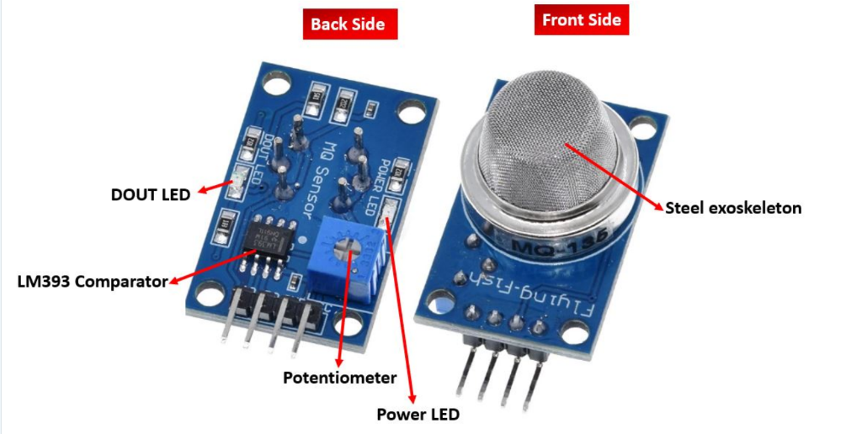MQ-135 sensor belongs to the MQ series that are used to detect different gasses present in the air. The MQ-135 sensor is used to detect gases such as NH3, NOx, alcohol, Benzene, smoke,CO2 ,etc. steel exoskeleton houses a sensing device within the gas sensor module.

#### **Pinout**

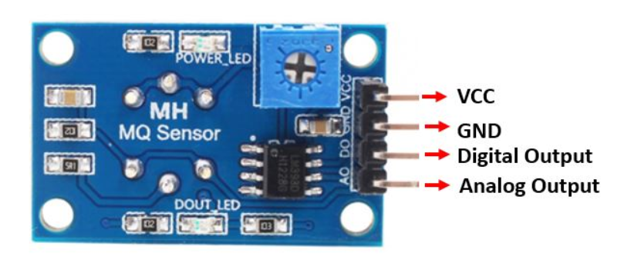

##### **MQ-135 Sensor Pinout**

##### This sensor has 4 pins:

##### 5V: Module power supply – 5 V

##### GND: Ground

##### DOUT: Digital output

##### AOUT: Analog output

**Circuit**

The following circuit shows how you should connect Arduino to MQ-135 module. Connect wires accordingly.

The MQ-135 sensor module consists of four pins namely VCC, GND, DO, and DO. The table below gives a brief description of them.

| **Pin** | **Description** |
| --- | --- |
| VCC | Positive power supply pin that powers up the sensor module. |
| GND | Reference potential pin. |
| AO | Analog output pin. It generates a signal proportional to the concentration of gas vapors coming in contact with the sensor. |
| DO | Digital Output pin. It also produces a digital signal whose limit can be set using the in-built potentiometer. |

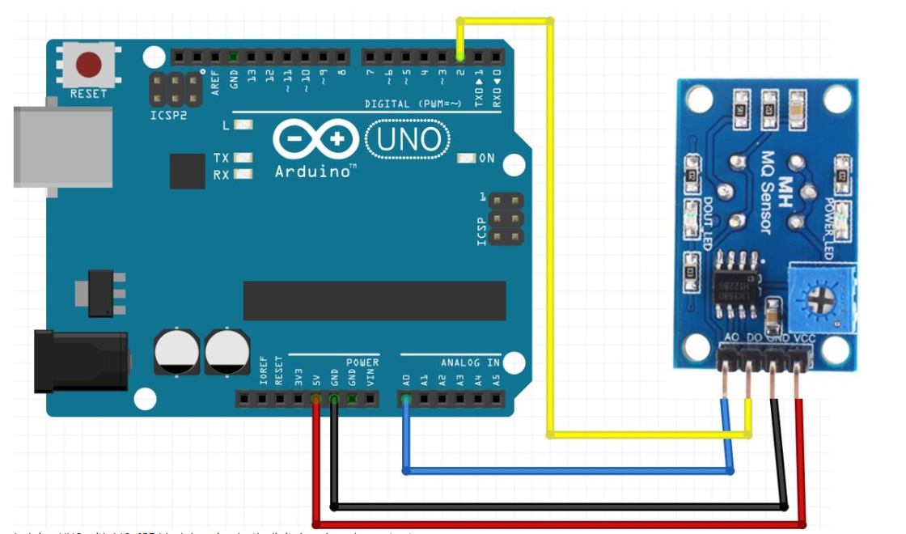

1. **Code/Program:**

#include "MQ135.h"

int sensorVal, digitalVal;

void setup() {

// put your setup code here, to run once:

Serial.begin(9600);

pinMode(13, OUTPUT);

pinMode(2, INPUT);

}

void loop() {

MQ135 gasSensor = MQ135(A0);

float air_quality = gasSensor.getPPM();

Serial.print("Air Quality: ");

Serial.print(air_quality);

Serial.println(" PPM");

// put your main code here, to run repeatedly:

sensorVal = analogRead(0);

digitalVal = digitalRead(2);

if(sensorVal > 400)

{

digitalWrite(13, HIGH);

}

Else

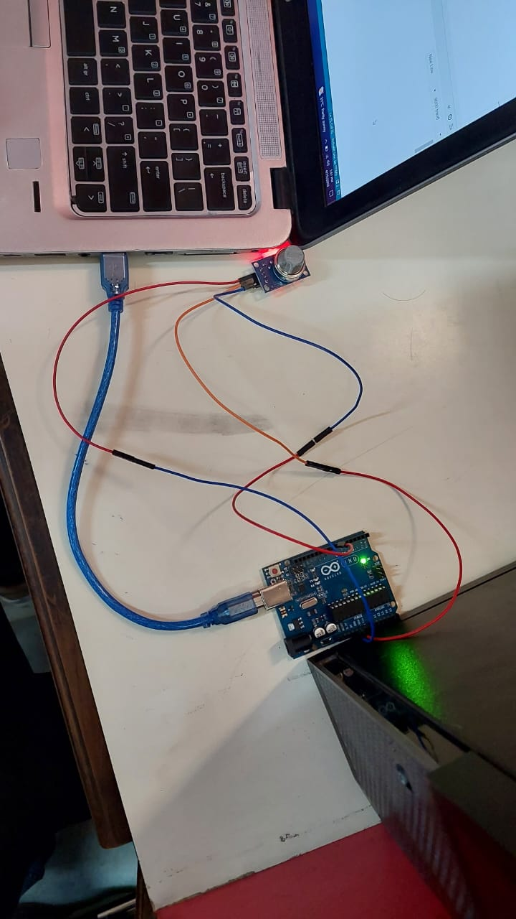 digitalWrite(13, LOW);

Serial.println(sensorVal, DEC);

Serial.println(digitalVal, DEC);

delay(500);

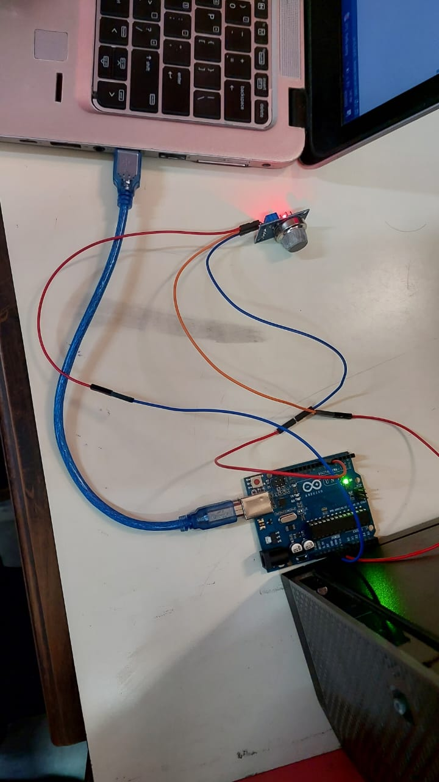}

**FIGURE: Circuit**

**FIGURE: Circuit**

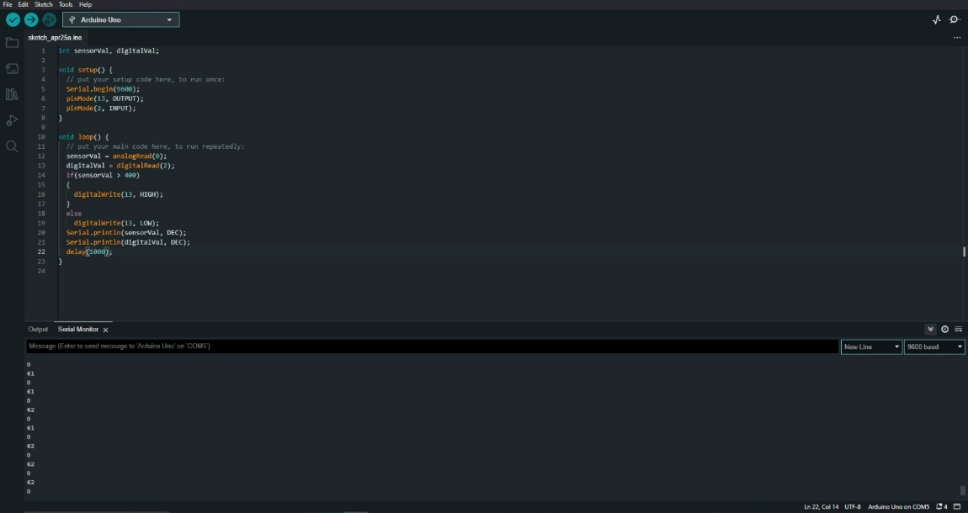**Output-**

**Figure- Analog Output Readings**

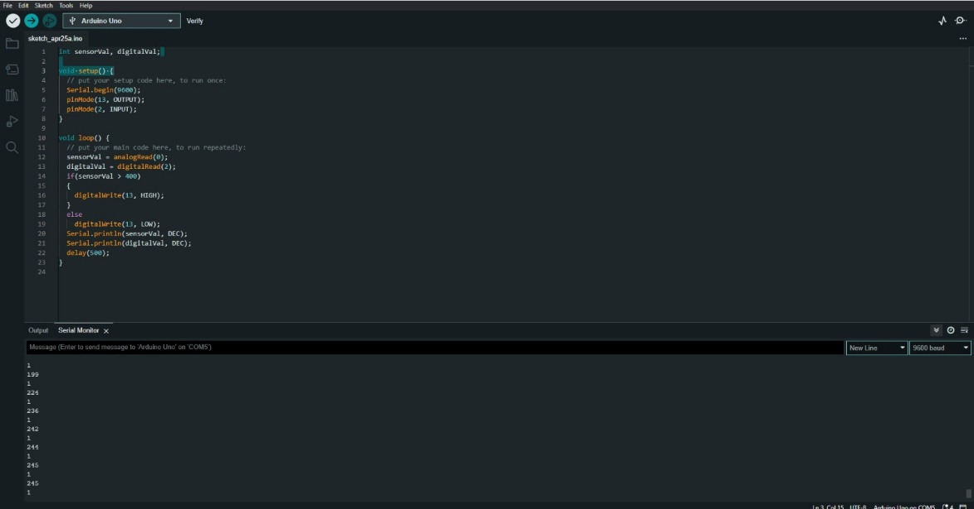

**Figure- Digital Output Readings**

**Result-**

In this experiment we learn how to display data generated by MQ-135 sensor on Serial Monitor using Arduino. And we display the readings in Analog and digital forms and the analysis in measures in PPM. MQ-135 is used for measuring air quality in various places.

**Learning outcomes (What I have learnt):**

* Learnt how to use MQ-135 to display the data on Serial Monitor using Arduino.
* Learnt how to code and read the data from the sensor.
* Leant how to measure readings in digital and analog forms.